# User Guide

The file provides clear instructions to help users navigate the app and its features, ensuring a smooth experience. It serves as a quick reference for common tasks.

Creating a user-friendly interface for an app is crucial and essential for enhancing User Experience. Therefore, we are planning to build the following interface for our app.

**Login Page**  
This page allows users to log in or create a new account to access the app.

* **Login Form:** Users can enter their **Username** and **Password** to log in.
* **Sign-Up Prompt:** If users don't have an account, they can tap on the **Sign Up** link to create a new account.

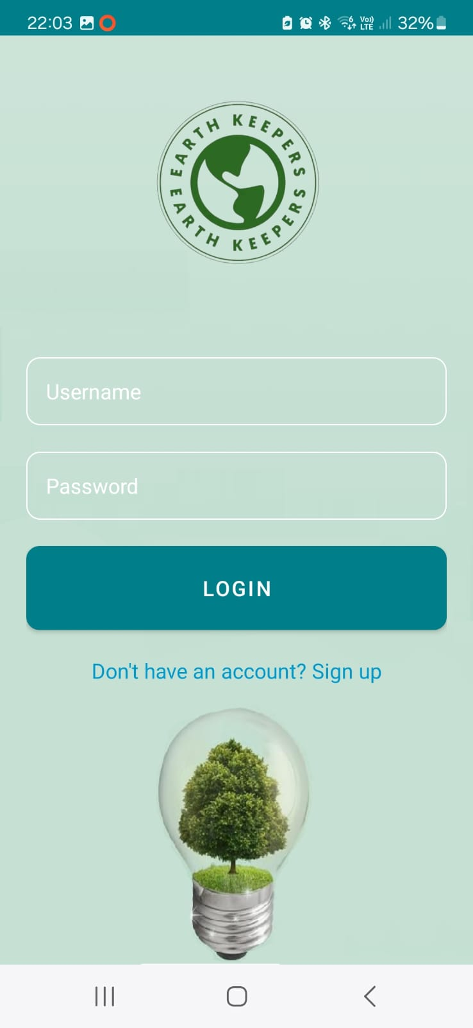

*Figure 1: Login page*

**Sign-Up page:**

* **Personal Information:** Users need to enter their **First Name**, **Last Name**, **Email**, and set a **Password**.
* **Gender Selection:** Options include **Male**, **Female**, and **Other**.
* **Preferred Hand:** Users can select either **Left-Handed** or **Right-Handed** for customization during the app’s usage.

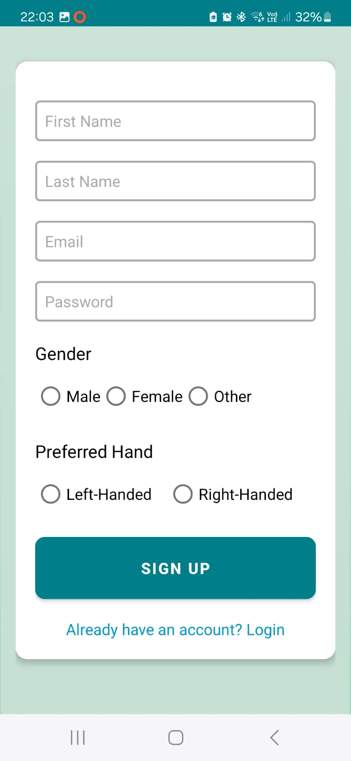

*Figure 2: sign-up page*

**Home Page**

The Home Page is the main hub for navigating the app. It includes several key buttons and information:

* **Profile Button:** Access this to view your profile and personal information, including your name and stats.
* **Start Button:** Tap this to begin a new session of waste detection.
* **Player’s High Scores Button:** View the top scores of other players and their collected points.
* **Help Button:** Get explanations on how the app works and how to use its features.

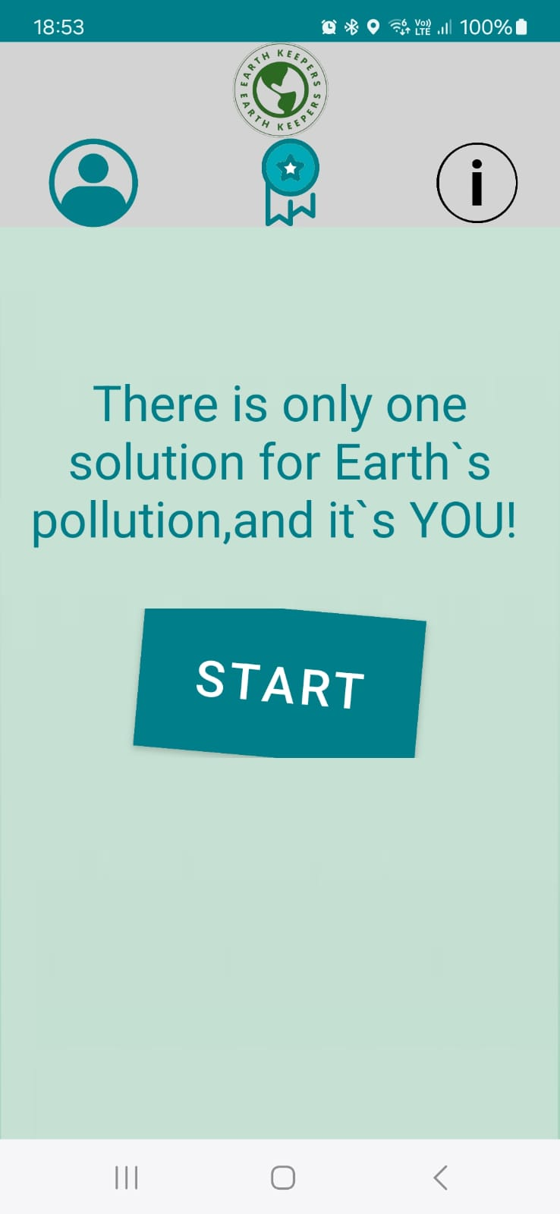

*Figure 3: Home page for the app*

**Pre-Session Page**

In this page, you should take one photo of all the trash items you want to collect during this session. Afterward, the app will calculate the maximum possible points you can earn and display the detected trash items along with their corresponding points.

Clicking the Start Button on the Home Page opens the Pre-Session Page, which includes:

* **Photo Capture Area**: This page allows the user to take a photo of the trash he wants to collect.
* **Retake Photo Button**: Use this button to retake the photo.
* **Start Collecting Button**: Use this button to proceed to the Real-Time Waste Detection Page and start the trash collection session.

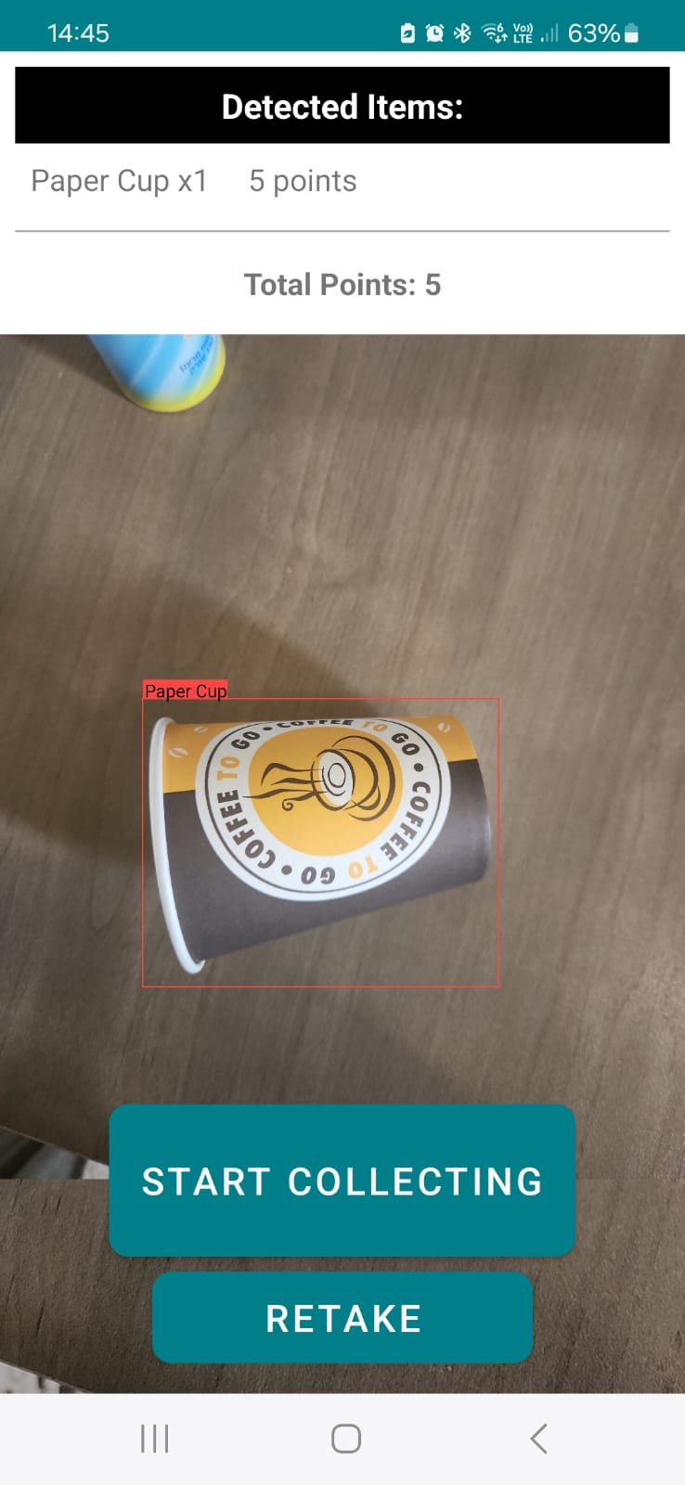

*Figure 4:* Pre-Session Page

**Real-Time Waste Detection Page**

Clicking the “**Start Collecting” Button** on the Pre-Session Page opens the Real-Time Waste Detection Page, which includes:

* **END Button:** Use this button to end the session and save your earned points.
* **Video Capture Area:** This section displays the live video feed for detecting and collecting waste.

On this page, you begin collecting trash items, one item at a time. The app must first detect that your hand is open, and once you hold an item, it will detect that your hand is closed. After holding the item, you should wait for 2-3 seconds until you hear a sound that indicates what item you're holding and the points you've earned. If you don't hear anything (though this is unlikely), you should drop the item and try again.

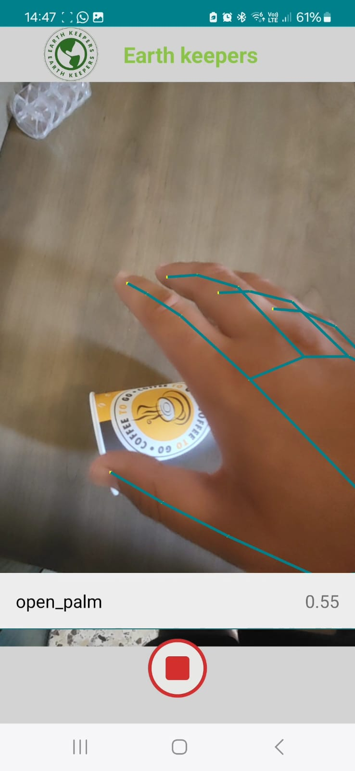

*Figure 5: Snapshot of a trash collection session in progress*

**Personal Info Page**

Access the Personal Info Page by clicking the **Profile Button** on the Home Page. This page provides:

* **Personal Information:** Displays your first and last names, along with your current collected points.
* **Total Points:** Shows the total number of points you have collected since joining the app.
* **Best Session Score:** Indicates your highest score achieved in a single session.
* **Hand Preference:** Displays your preferred hand for collecting trash. You can change this preference by clicking on the hand icon or button.
* **Logout Button:** Click this to log out of the app.

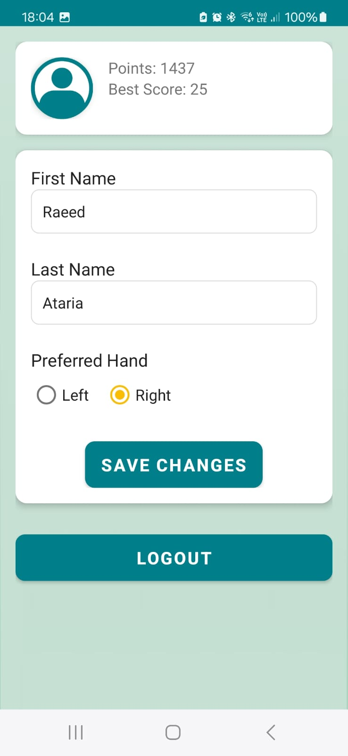

*Figure 6: Personal Info Page*

**Best Scores Page**

Access the Best Scores Page by clicking the **Player’s High Scores Button** on the Home Page. This page features:

* **Top Scores Table:** Displays a table of the top scores achieved by various players.
* **Player Rankings:** Shows the rank of each player, including yourself.
* **Highlighted User:** Your own ranking is highlighted in green.

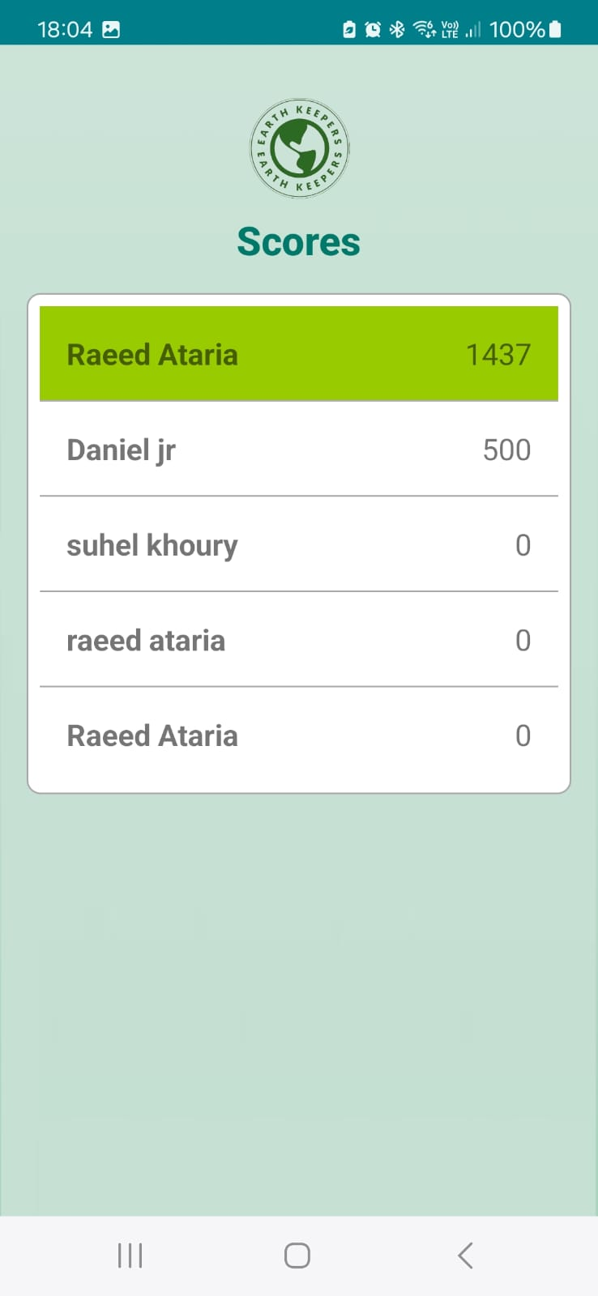

*Figure 7: Best Scores Page*

**User Help page:**



By clicking on the help icon (located on the right), you can access the user help page, which provides assistance for any feature or issue you encounter while using the app.

The following figure shows a portion of the User Guide within the app. You can access the complete User Guide directly in the app.

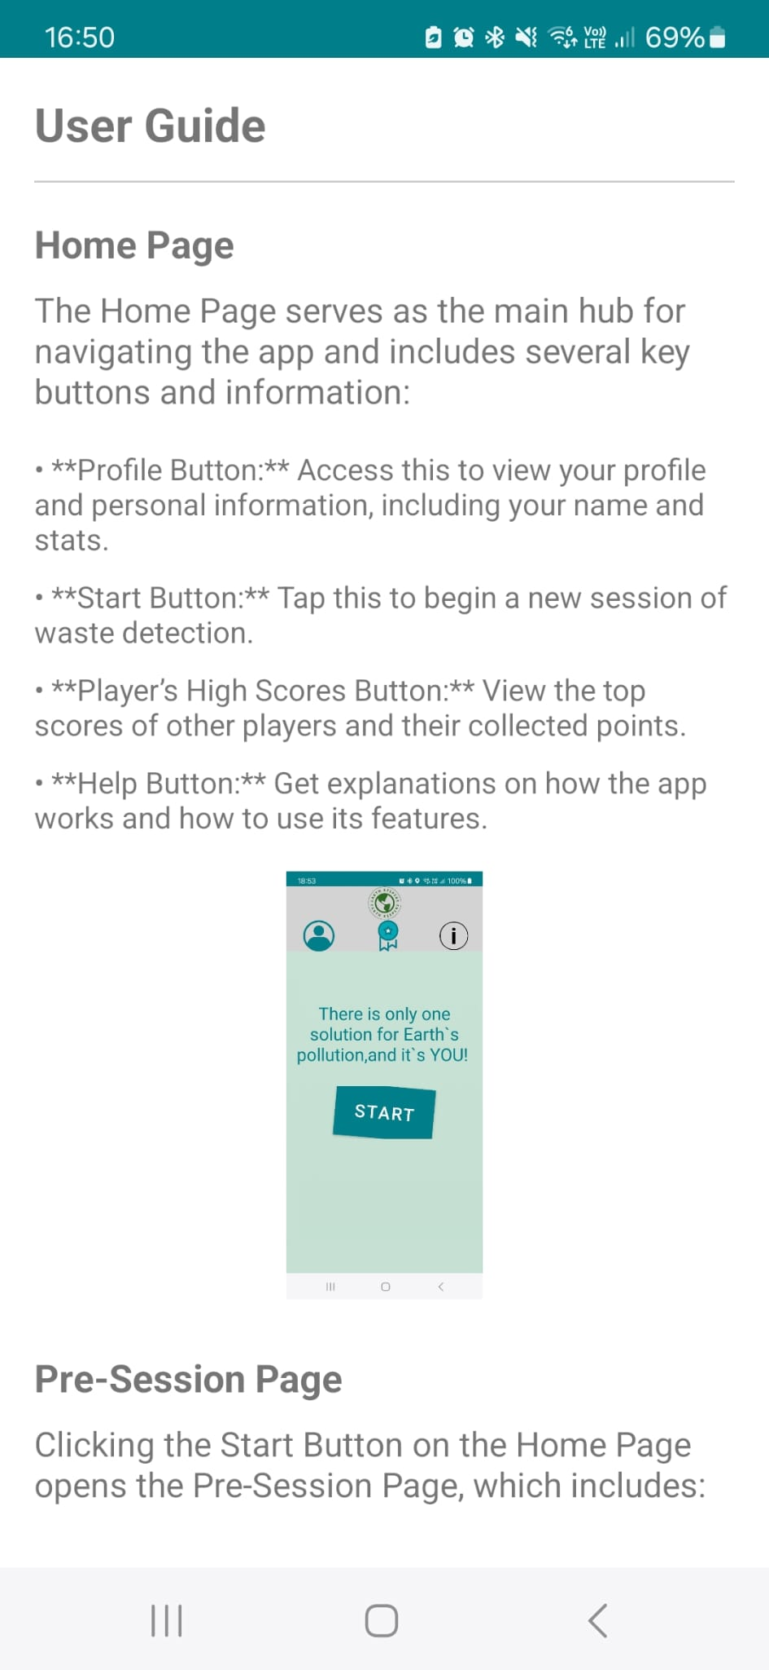

*Figure 8: User help Page*